HANOI UNIVERSITY OF SCIENCE AND TECHNOLOGY

School of Information and communications technology

Software Design Document

Version 1.3

EcoBike Application

Subject: ITSS Software Management

Group 6

| No. | Student Name | Student ID |
| --- | --- | --- |
| 1 | Nguyen Thi Minh Chau | 20184238 |
| 2 | Tran Le Hai Duong | 20184248 |
| 3 | Nguyen Thanh Long | 20184287 |

*Hanoi, 01/2022*

# Table of Contents

**Table of Contents** **3**

**List of Figures** **6**

**List of Tables** **7**

**1. Introduction** **8**

1.1. Objective 8

1.2. Scope 8

1.3. Glossary 8

1.4. References 9

**2. Overall Description** **10**

2.1. General Overview 10

2.2. Assumptions/Constraints/Risks 11

2.2.1. Assumptions 11

2.2.2. Constraints 11

2.2.3. Risks 11

**3. System Architecture and Architecture Design** **12**

3.1. Architectural Patterns 12

3.2. Interaction Diagrams 12

3.2.1. Communication Diagrams 12

3.2.2. Sequence Diagrams 15

3.3. Analysis Class Diagrams 18

3.4. Unified Analysis Class Diagram 21

3.5. Security Software Architecture 21

**4. Detailed Design** **22**

4.1. User Interface Design 22

4.1.1. Screen Configuration Standardization 22

4.1.2. Screen Transition Diagrams 22

4.1.3. Screen Specifications 22

4.1.3.1. Splash Screen 22

4.1.3.2. Main Screen 23

4.1.3.3. Dock Screen 23

4.1.3.4. Bike Screen 24

4.1.3.5. Payment Method Screen 25

4.1.3.6. Deposit screen 25

4.1.3.7. Payment screen 25

4.2. Data Modeling 27

4.2.1. Conceptual Data Modeling 27

4.2.2. Database Design 27

4.2.2.1. Database Management System 27

4.2.2.2. Database Diagram 28

4.2.2.3. Database Detail Design 28

4.3. Non-Database Management System Files 35

4.4. Class Design 35

4.4.1. General Class Diagram 35

4.4.2. Class Diagrams 36

4.4.2.1. Class Diagram for Package BikeInformation 36

4.4.2.2. Class Diagram for Subsystem RentBike 37

4.4.2.3. Class Diagram for Subsystem InterBank 37

4.4.3. Class Design 38

4.4.3.1. Class RentBikeController 38

4.4.3.2. Class ReturnBikeController 39

4.4.3.3. Class PaymentController 41

4.4.3.4. Class BikeInformationScreenHandler 43

**5. Design Considerations** **45**

5.1. Goals and Guidelines 45

5.2. Architectural Strategies 45

5.3. Coupling and Cohesion 45

5.3.1. Coupling 45

5.3.1.1. Content coupling 45

5.3.1.2. Common coupling 46

5.3.1.3. Control coupling 46

5.3.1.4. Stamp coupling 46

5.3.1.5. Data coupling 46

5.3.2. Cohesion 47

5.3.2.1. Coincidental cohesion 47

5.3.2.2. Logical cohesion 47

5.3.2.3. Temporal cohesion 47

5.3.2.4. Procedure cohesion 47

5.3.2.5. Communicational cohesion 47

5.3.2.6. Sequential cohesion 48

5.3.2.7. Information cohesion 48

5.3.2.8. Functional cohesion 48

5.4. Design Principles 48

5.5. Design Patterns 48

# List of Figures

*Figure 1.1: General use case diagram 11*

*Figure 3.1: Communication Diagram for Rent Bike Use Case 13*

*Figure 3.2: Communication Diagram for Deposit Use Case 13*

*Figure 3.3: Communication Diagram for Update Payment Method Use Case 14*

*Figure 3.4: Communication Diagram for Return Bike Use Case 14*

*Figure 3.5: Communication Diagram for Return Deposit Use Case 15*

*Figure 3.6: Communication Diagram for Pay For Rental Use Case 15*

*Figure 3.7: Sequence Diagram for Rent Bike Use Case 16*

*Figure 3.8: Sequence Diagram for Deposit Use Case 16*

*Figure 3.9: Sequence Diagram for Update Payment Method Use Case 17*

*Figure 3.10: Sequence Diagram for Return Bike Use Case 17*

*Figure 3.11: Sequence Diagram for Return Deposit Use Case 18*

*Figure 3.12: Sequence Diagram for Pay For Rental Use Case 18*

*Figure 3.13: Class Diagram for View Bike Use Case 19*

*Figure 3.14: Class Diagram for View Bike Use Case 19*

*Figure 3.15: Class Diagram for Deposit Use Case 20*

*Figure 3.16: Class Diagram for Return Bike Use Case 20*

*Figure 3.17: Class Diagram for Return Deposit Use Case 21*

*Figure 3.18: Class Diagram for Pay Rental Use Case 21*

*Figure 3.19: Unified Class Diagram for EcoBike Application 21*

*Figure 4.1: Screen Transition Diagram for EcoBike Application 23*

*Figure 4.2. ER Diagram for EcoBike Application 28*

*Figure 4.3. Database Diagram for EcoBike Application 29*

*Figure 4.4. General Class Diagram for EcoBike Application 36*

*Figure 4.5. Class Diagram for Package BikeInformation 37*

*Figure 4.6. Class Diagram for Subsystem RentBike 38*

*Figure 4.7. Class Diagram for Subsystem InterBank 38*

*Figure 4.8. RentBikeController Class Diagram 39*

*Figure 4.9. ReturnBikeController Class Diagram 40*

*Figure 4.10. PaymentControllerClass Diagram 42*

# List of Tables

*Table 1.1: Terms used in the document 10*

*Table 4.1. Splash Screen Specification 24*

*Table 4.2. Main Screen Specification 24*

*Table 4.3. View Dock Screen Specification 25*

*Table 4.4. View Bike Screen Specification 25*

*Table 4.5. Payment Method Screen Specification 26*

*Table 4.6. Deposit Screen Specification 26*

*Table 4.7. Payment Screen Specification 27*

*Table 4.8. Customer table design 29*

*Table 4.9. Administrator table design 30*

*Table 4.10. Dock table design* 30

*Table 4.11. Bike table design* 31

*Table 4.12. Bike In Dock table design* 31

*Table 4.13. Bike Status table design* 32

*Table 4.14. Invoice table design 32*

*Table 4.15. Transaction table design 33*

*Table 4.16. Rent Bike table design 33*

*Table 4.17. Credit Card table design 34*

*Table 4.18. RentBikeController attributes 39*

*Table 4.19. RentBikeController operations 40*

*Table 4.20. ReturnBikeController attributes 41*

*Table 4.21. ReturnBikeController operations 41*

*Table 4.22. PaymentController attributes 42*

*Table 4.23. PaymentController operations 43*

*Table 4.24.* BikeInformationScreenHandler *operations 45*

*Table 4.25.* BikeInformationScreenHandler *operations 45*

# 1. Introduction

## 1.1. Objective

This Software Design Document provides the design of EcoBike Application. It will explain the purpose and features of the system, the interfaces of the system, what the system will do, the constraints under which it must operate and how the system will react to external stimuli.

The expected audience is the user of the EcoBike Application, including Mrs. Trang and the ITSS Software development Course’s students, the developer of the project, and the people who will maintain the EcoBike Application.

## 1.2. Scope

This document contains a complete description of the design of EcoBike Application.

The EcoBike Application is a mobile application that allows the resident of Hanoi to use the EcoBike service, including finding out information of nearby docks and renting bikes for personal usage and online payment for the renting process.

The objective of the EcoBike Application is to serve a maximum of 100.000 users concurrently, with a friendly and easy-to-use user interface with the aim of helping the user to find the most suitable place to rent or return the bike.

## 1.3. Glossary

| **Term** | **Definition** |
| --- | --- |
| Administrator | The person who uses EcoBike application system for the purposes of monitoring list of bicycles in the system |
| Admin | as “administrator” |
| Bicycle | The transportation mean to be rent in this application system |
| Bike | as “bicycle” |
| Card number | The ID number of the credit card, printed on the credit card |
| Cardholder name | The name of the owner of the credit card, printed on the credit card |
| Credit card | A card connected to the interbank, used for performing transaction |
| Customer | The person who uses EcoBike application system for the purposes of renting bike |
| Database | Collection of all information monitored by this system |
| Deposit | An amount of money customer has to pay at first in order to rent a bike |
| Dock | A place where bicycles are put |
| Interbank | The organization in charges of performing payment and return deposit transactions in the system |
| Payment | An amount of money customer has to pay to rent a bike, including deposit and rental fee |
| Rent a bike | The action of using a bike in a period of time, with paying deposit and rental fee |
| Rental fee | An amount of money customer has to pay, outside of the deposit, which depends on the rental time |
| Rental time | The time period when the bike is being rented |
| Return a bike | The action of stopping using a bike after having rented |
| Software Requirement Specification | A document that completely describes all of the functions of a proposed system and the constraints under which it must operate. For example, this document. |
| Station | as “dock” |
| Transaction | The action of paying for bike deposit, bike rental or returning deposit |
| User | Customer or Administrator |

*Table 1.1: Terms used in the document*

## 1.4. References

| [1] | Centers for Medicare & Medicaid Services, "System Design Document Template," [Online]. Available: https://www.cms.gov/Research-Statistics-Data-and-Systems/CMS-Information-Technology/XLC/Downloads/SystemDesignDocument.docx. |
| --- | --- |

# 2. Overall Description

## 2.1. General Overview

EcoBike Application is a desktop application through which users can view docks and rent or return bikes. We design a clean and clear interface for users. Users can interact with the apps by clicking on the interface, and the request is processed by the controller.

Additionally, we have our own database to store information and data that is related to our system, as well as a subsystem to proceed payment transactions.

The below figure is the general use-case diagram for our design:

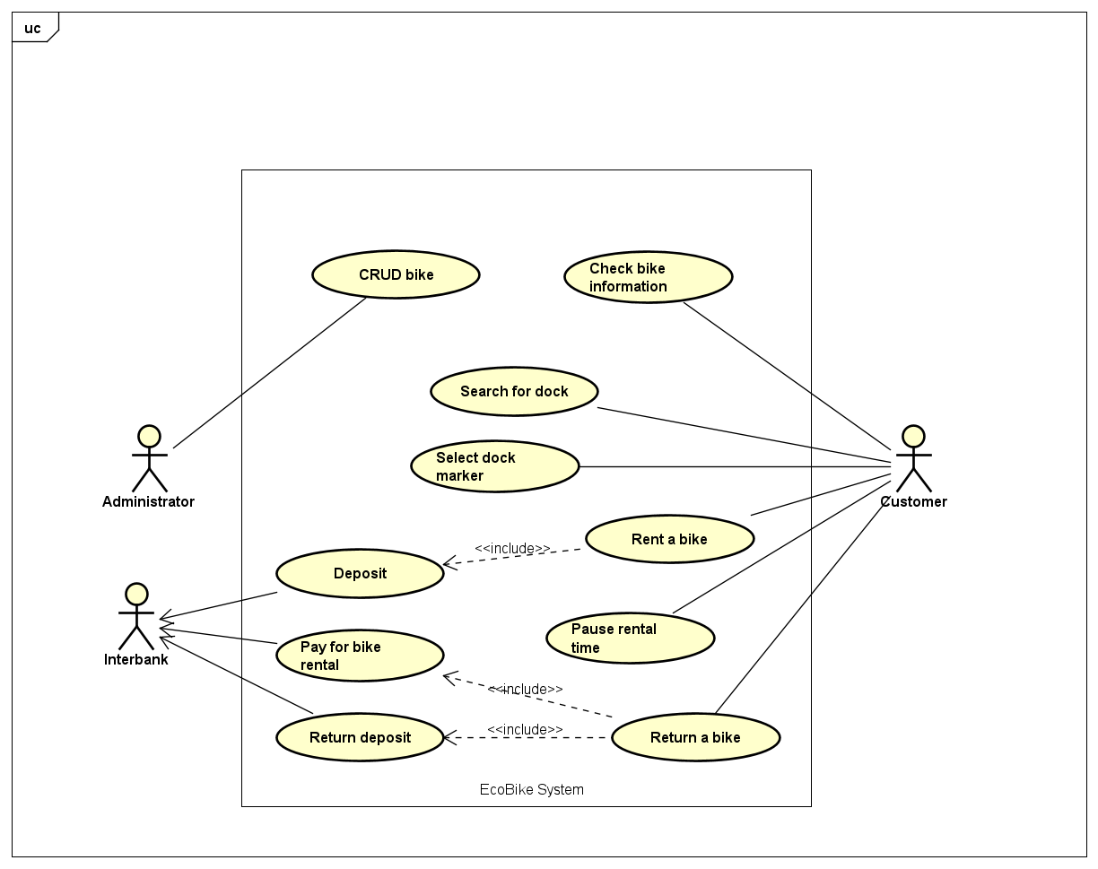

*Figure 1.1: General use case diagram*

## 2.2. Assumptions/Constraints/Risks

### 2.2.1. Assumptions

In order to use the application, users must have an internet connection as well as a personal computer to run the app. We would also require the latest version of JRE in order to ensure the application’ stability.

### 2.2.2. Constraints

· *Hardware or software environment*

· *End-user environment*

· *Availability or volatility of resources*

· *Standards compliance*

· *Interoperability requirements*

· *Interface/protocol requirements*

· *Licensing requirements*

· *Data repository and distribution requirements*

· *Security requirements (or other such regulations)*

· *Memory or other capacity limitations*

· *Performance requirements*

· *Network communications*

· *Verification and validation requirements (testing)*

· *Other means of addressing quality goals*

· *Other requirements described in the Requirements Document*

### 2.2.3. Risks

# 3. System Architecture and Architecture Design

## 3.1. Architectural Patterns

*<Specify and briefly describe the chosen architectural patterns and the reasons why they were chosen>*

## 3.2. Interaction Diagrams

### 3.2.1. Communication Diagrams

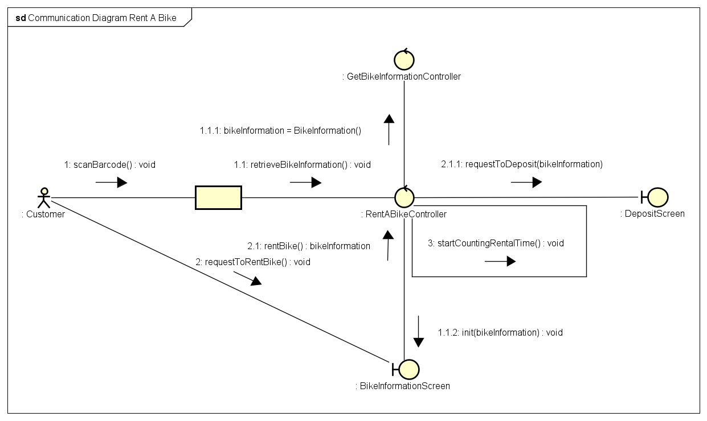

*Figure 3.1: Communication Diagram for Rent Bike Use Case*

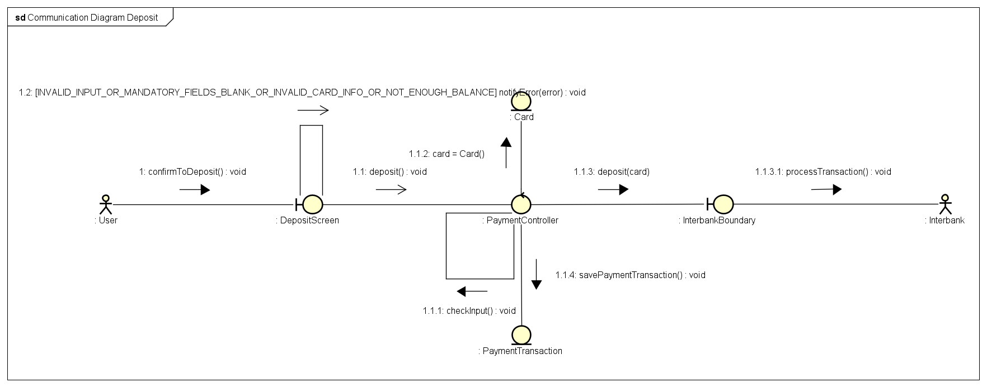

*Figure 3.2: Communication Diagram for Deposit Use Case*

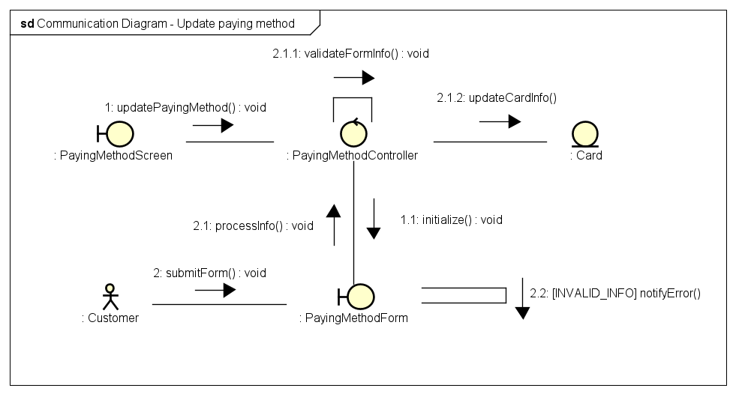

*Figure 3.3: Communication Diagram for Update Payment Method Use Case*

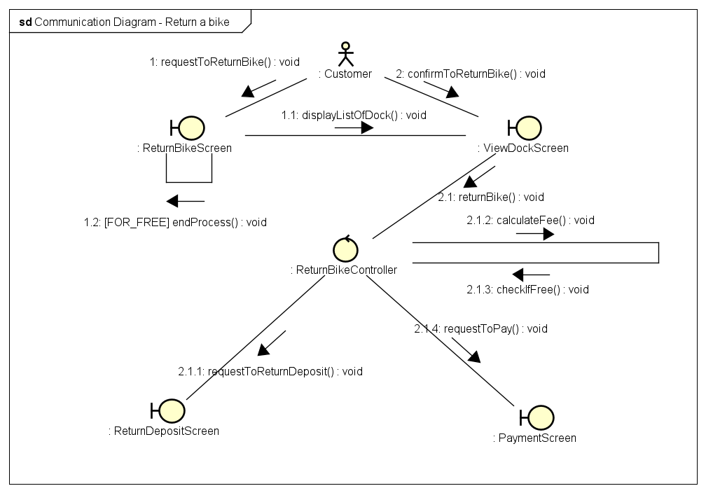

*Figure 3.4: Communication Diagram for Return Bike Use Case*

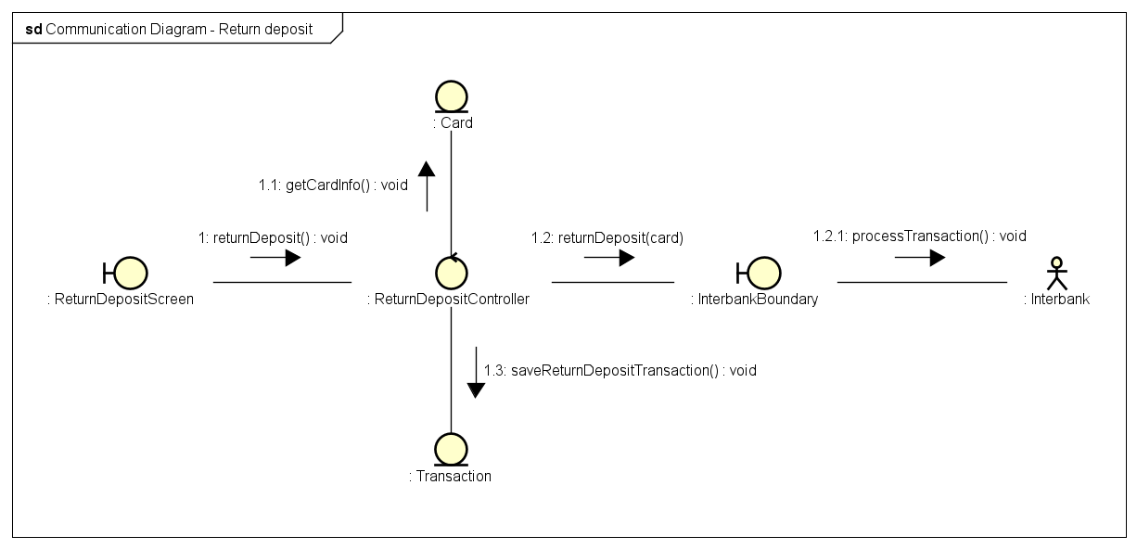

*Figure 3.5: Communication Diagram for Return Deposit Use Case*

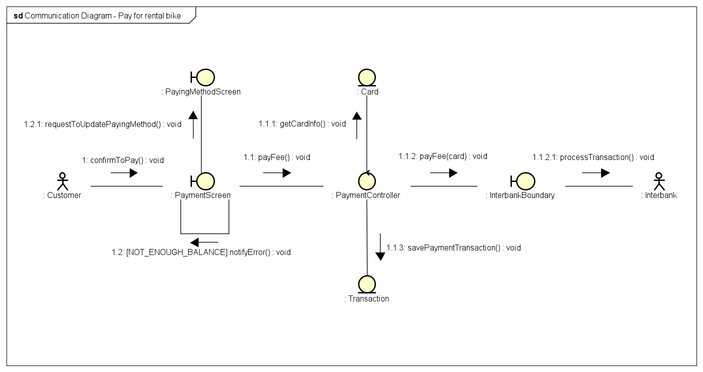

*Figure 3.6: Communication Diagram for Pay For Rental Use Case*

### 3.2.2. Sequence Diagrams

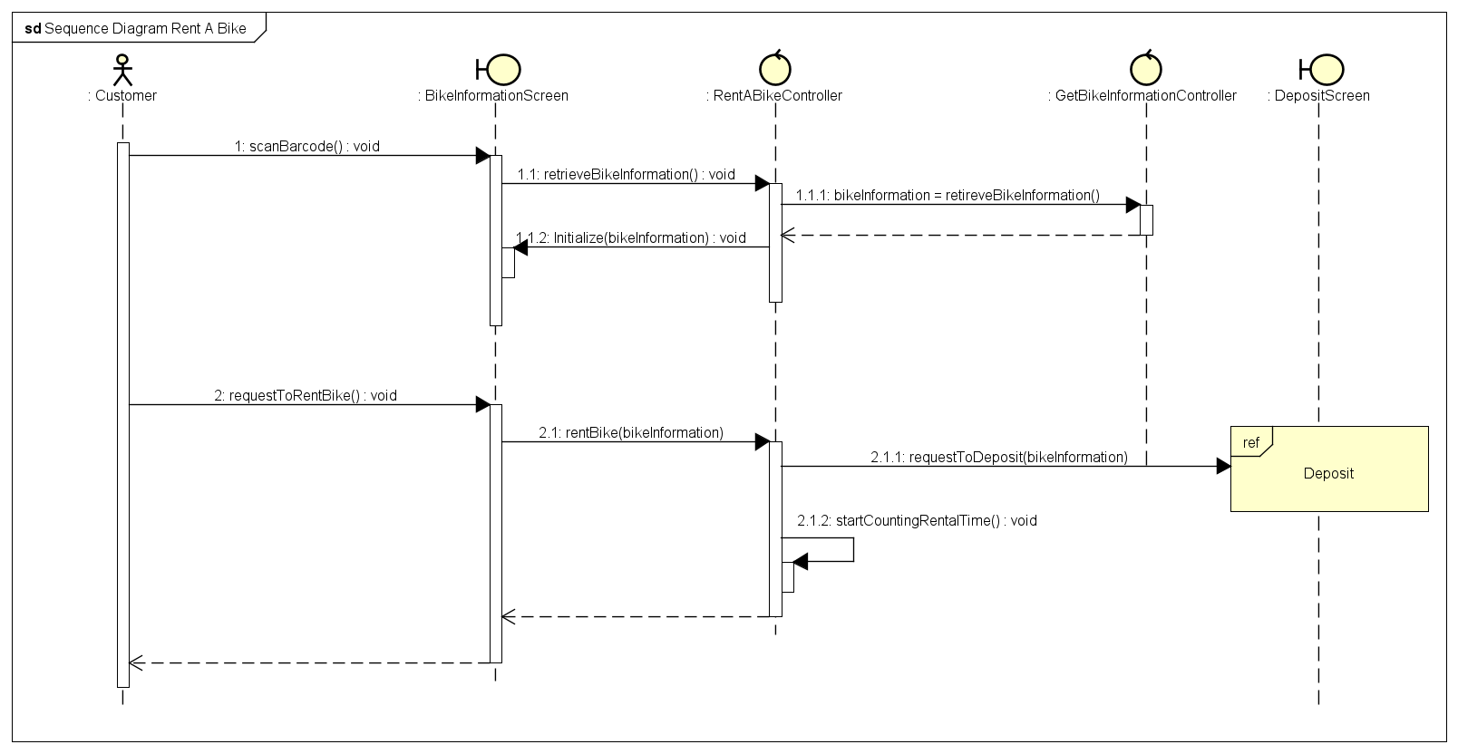

*Figure 3.7: Sequence Diagram for Rent Bike Use Case*

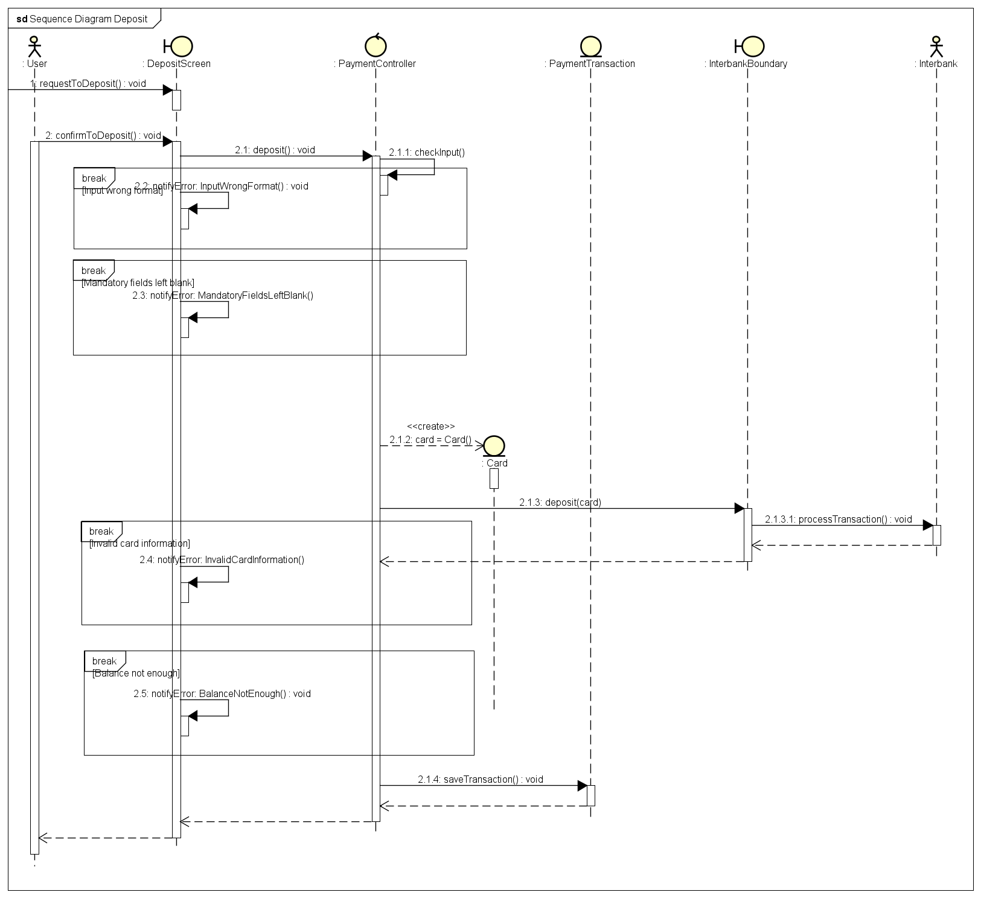

*Figure 3.8: Sequence Diagram for Deposit Use Case*

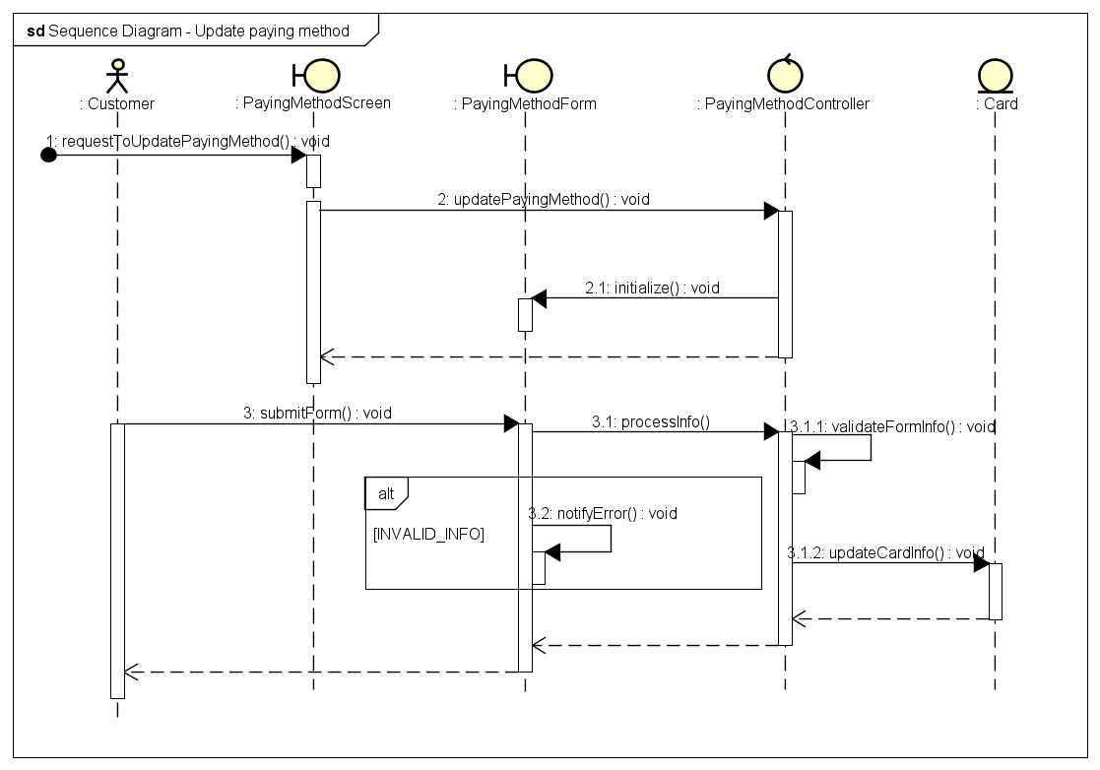

*Figure 3.9: Sequence Diagram for Update Payment Method Use Case*

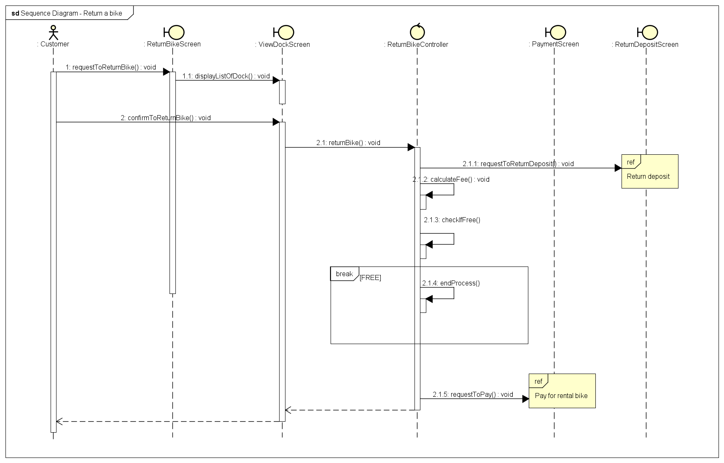

*Figure 3.10: Sequence Diagram for Return Bike Use Case*

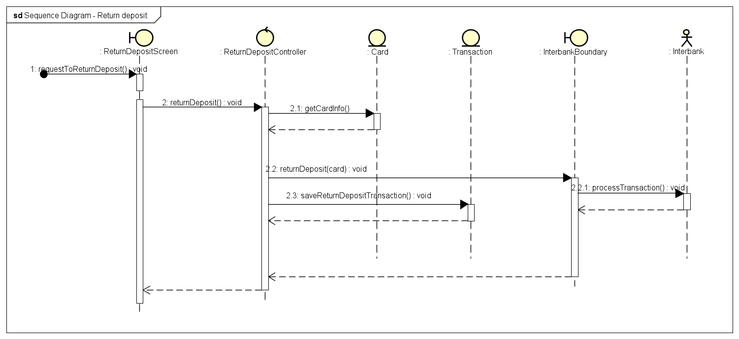

*Figure 3.11: Sequence Diagram for Return Deposit Use Case*

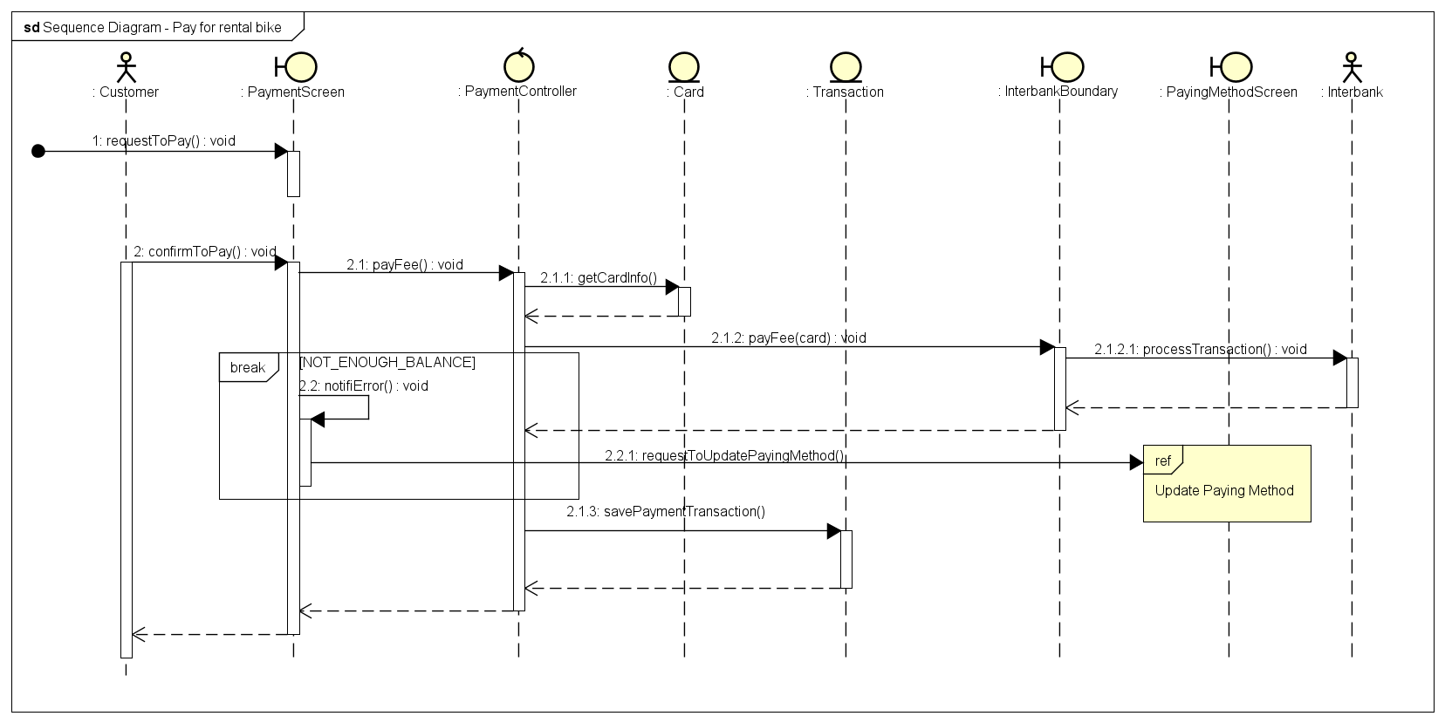

*Figure 3.12: Sequence Diagram for Pay For Rental Use Case*

## 3.3. Analysis Class Diagrams

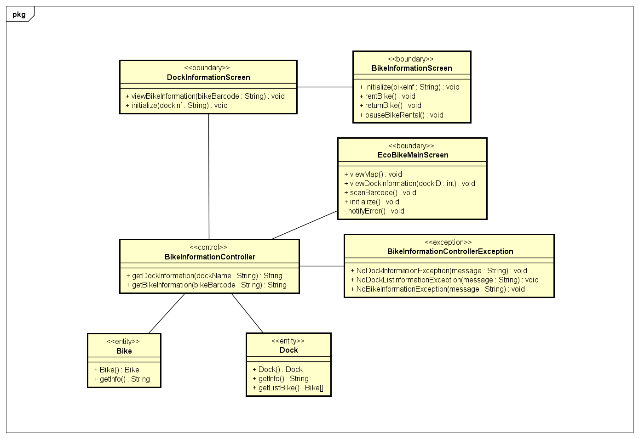

*Figure 3.13: Class Diagram for View Bike Use Case*

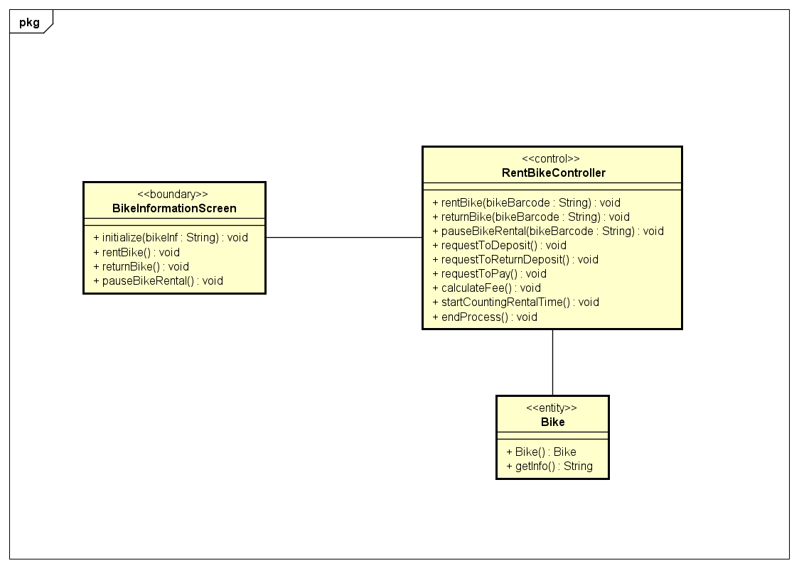

*Figure 3.14: Class Diagram for View Bike Use Case*

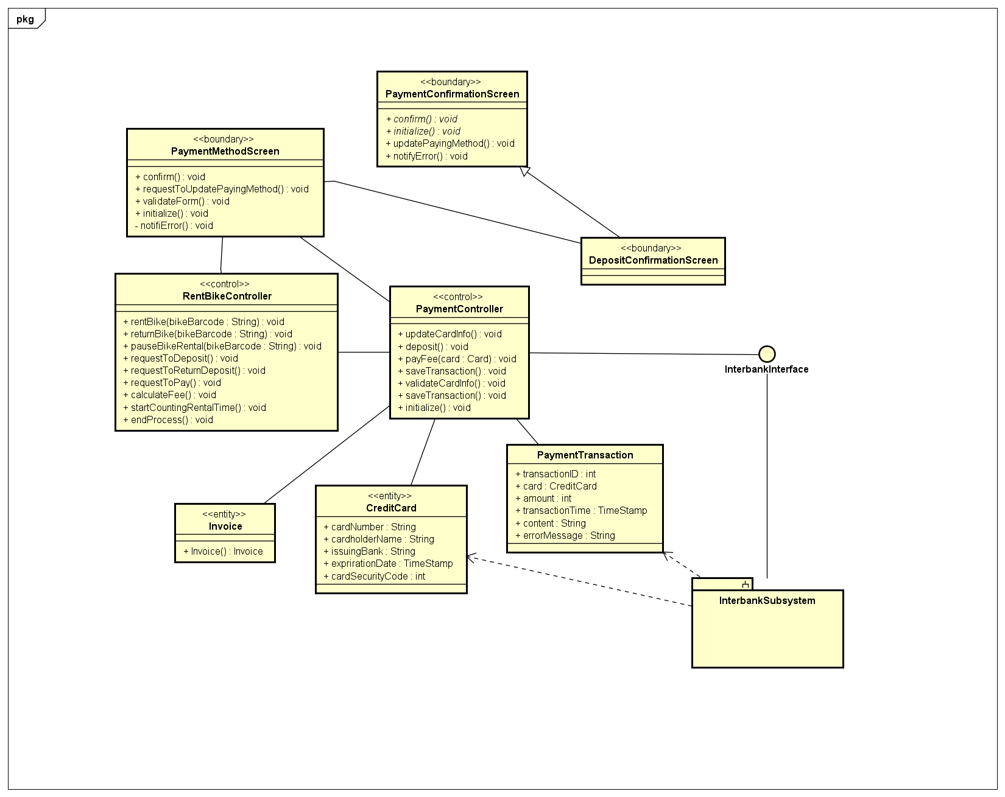

*Figure 3.15: Class Diagram for Deposit Use Case*

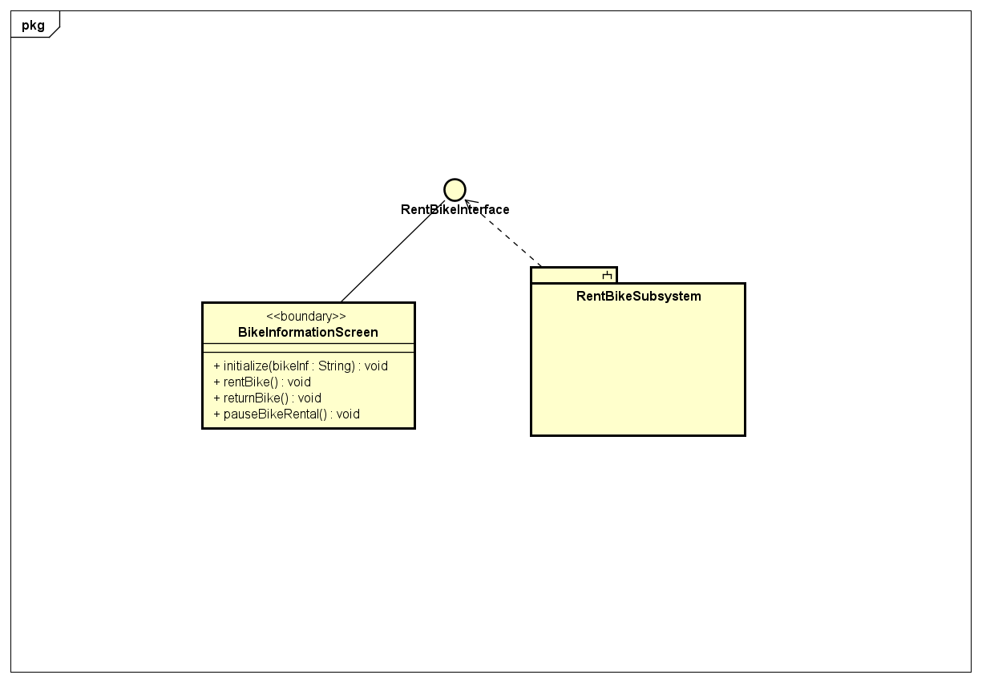

*Figure 3.16: Class Diagram for Return Bike Use Case*

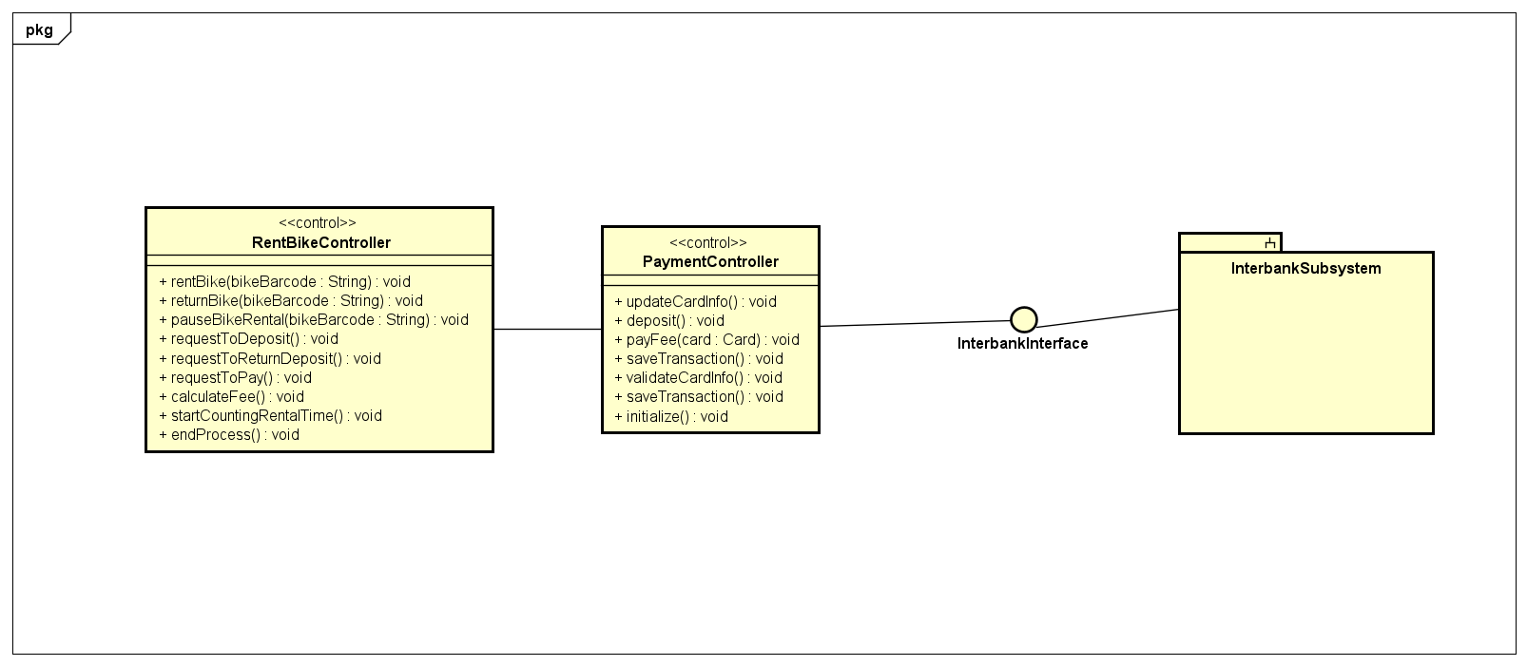

*Figure 3.17: Class Diagram for Return Deposit Use Case*

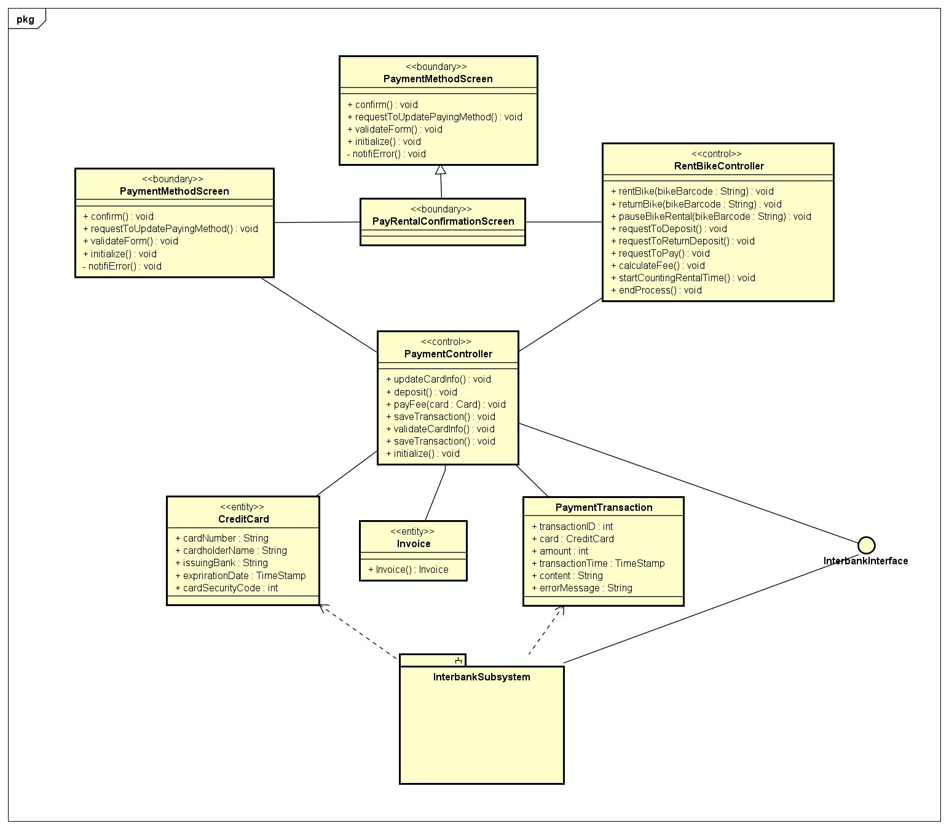

*Figure 3.18: Class Diagram for Pay Rental Use Case*

## 3.4. Unified Analysis Class Diagram

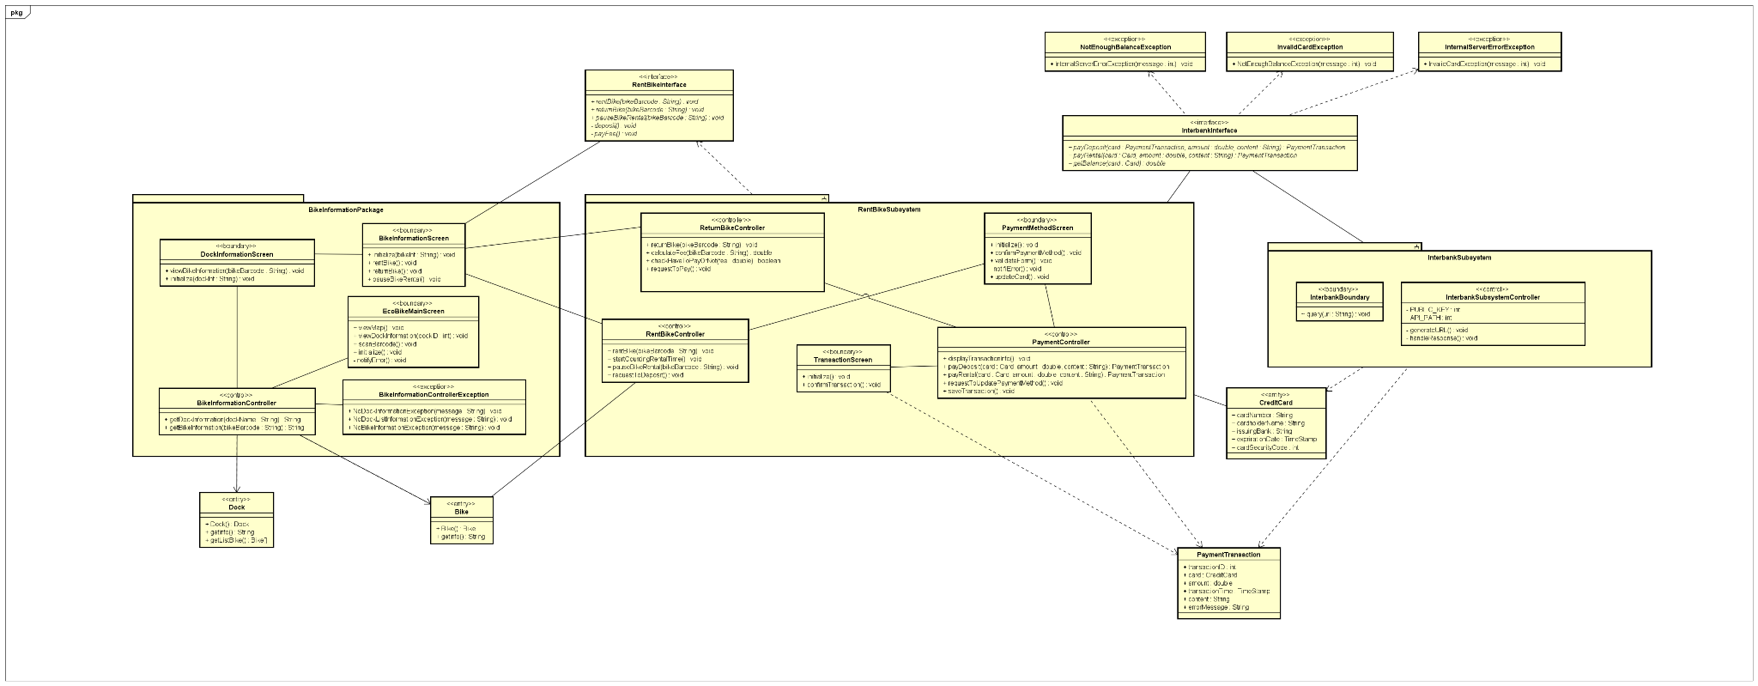

*Figure 3.19: Unified Class Diagram for EcoBike Application*

## 3.5. Security Software Architecture

In this project, we will not consider features such as user authentication (e.g., sign up, sign in, sign out), we only focus on features related to rent and return bikes.

# 4. Detailed Design

## 4.1. User Interface Design

### 4.1.1. Screen Configuration Standardization

Display

***Screen resolution:*** 1366x768px

***Number of colors supported:*** 16,177,216 colors

Screen

***Size:*** 1200 x 600px

***Main background color:*** #e6ebbc (R: 230, G: 235, B: 188)

***Location of buttons:*** Bottom center of the frame

***Logo:*** 100x100 px

***Header logo:*** 100x100 px, located top left of the screen

***Header/Screen title:*** Segoe UI, Bold, 24px, black

***Numbers:*** comma for thousand separation, dot for decimal separation

***Text:*** Segoe UI, size at most 24px

***Frame border (if necessary):*** bounded rectangle, dashed line with width of 3px, color #afc139 (R: 175, G:193, B:57)

### 4.1.2. Screen Transition Diagrams

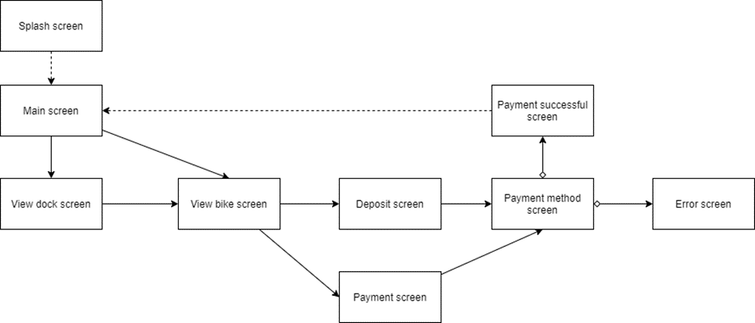

*Figure 4.1: Screen Transition Diagram for EcoBike Application*

### 4.1.3. Screen Specifications

#### 4.1.3.1. Splash Screen

| ***EcoBike Software*** | | ***Date of creation*** | ***Approved by*** | ***Reviewed by*** | ***Person in charge*** |
| --- | --- | --- | --- | --- | --- |
| ***Screen specification*** | ***Splash screen*** | *28/10/2021* |  |  | *Chau* |
|  | | ***Control*** | ***Operation*** | ***Function*** | |
| *Main area* | *None* | *Introduce the application* | |

*Table 4.1. Splash Screen Specification*

#### 4.1.3.2. Main Screen

| ***EcoBike Software*** | | ***Date of creation*** | ***Approved by*** | ***Reviewed by*** | ***Person in charge*** |
| --- | --- | --- | --- | --- | --- |
| ***Screen specification*** | ***Main screen*** | *28/10/2021* |  |  | *Chau* |
|  | | ***Control*** | ***Operation*** | ***Function*** | |
| *Header logo* | *Click* | *Return immediately to main screen* | |
| *Search bar* | *Type, select & click* | *Type in information and select search type to search for docks or bikes* | |
| *Main area* | *Initial* | *Display map at current location of users and nearby docks in term. The pins of docks can be clicked to see docks details* | |

*Table 4.2. Main Screen Specification*

#### 4.1.3.3. Dock Screen

| ***EcoBike Software*** | | ***Date of creation*** | ***Approved by*** | ***Reviewed by*** | ***Person in charge*** |
| --- | --- | --- | --- | --- | --- |
| ***Screen specification*** | ***View Dock screen*** | *28/10/2021* |  |  | *Chau* |
|  | | ***Control*** | ***Operation*** | ***Function*** | |
| *Logo* | *Click* | *Return to the main screen immediately* | |
| *Header* | *Initial* | *Display title of screen* | |
| *Dock information* | *Initial* | *Display dock information* | |
| *Return bike* | *Click* | *Allow user to start return bike process at the dock* | |
| *Bike list* | *Click* | *Display brief details about bikes available in the current dock. Allow choosing each bike to see detailed information* | |

*Table 4.3. View Dock Screen Specification*

#### 4.1.3.4. Bike Screen

| ***EcoBike Software*** | | ***Date of creation*** | ***Approved by*** | ***Reviewed by*** | ***Person in charge*** |
| --- | --- | --- | --- | --- | --- |
| ***Screen specification*** | ***View bike screen*** | *28/10/2021* |  |  | *Chau* |
|  | | ***Control*** | ***Operation*** | ***Function*** | |
| *Logo* | *Click* | *Return to the main screen immediately* | |
| *Header* | *Initial* | *Display title of screen* | |
| *Bike information* | *Initial* | *Display bike information* | |
| *Option pane* | *Click* | *Allow customer to perform renting, pause or return bike* | |

*Table 4.4. View Bike Screen Specification*

#### 4.1.3.5. Payment Method Screen

| ***EcoBike Software*** | | ***Date of creation*** | ***Approved by*** | ***Reviewed by*** | ***Person in charge*** |
| --- | --- | --- | --- | --- | --- |
| ***Screen specification*** | ***Paying method screen*** | *29/10/2021* |  |  | *Duong* |
|  | | ***Control*** | ***Operation*** | ***Function*** | |
| *Logo* | *Click* | *Return to the main screen immediately* | |
| *Header* | *Initial* | *Display title of screen* | |
| *Payment* | *Initial* | *Display information of paying method* | |
| *Button* | *Click* | *Allow customer confirm to the paying method* | |

*Table 4.5. Payment Method Screen Specification*

#### 4.1.3.6. Deposit screen

| ***EcoBike Software*** | | ***Date of creation*** | ***Approved by*** | ***Reviewed by*** | ***Person in charge*** |
| --- | --- | --- | --- | --- | --- |
| ***Screen specification*** | ***Payment screen*** | *29/10/2021* |  |  | *Long* |
|  | | ***Control*** | ***Operation*** | ***Function*** | |
| *Logo* | *Click* | *Return to the main screen immediately* | |
| *Header* | *Initial* | *Display title of screen* | |
| *Information of payment* | *Initial* | *Display information of payment* | |
| *Button* | *Click* | *Allow customer confirm to deposit the bike* | |

*Table 4.6. Deposit Screen Specification*

#### 4.1.3.7. Payment screen

| ***EcoBike Software*** | | ***Date of creation*** | ***Approved by*** | ***Reviewed by*** | ***Person in charge*** |
| --- | --- | --- | --- | --- | --- |
| ***Screen specification*** | ***Payment screen*** | *29/10/2021* |  |  | *Duong* |
|  | | ***Control*** | ***Operation*** | ***Function*** | |
| *Logo* | *Click* | *Return to the main screen immediately* | |
| *Header* | *Initial* | *Display title of screen* | |
| *Information of payment* | *Initial* | *Display information of payment* | |
| *Buttons* | *Click* | *Allow customer confirm to pay or update card info* | |

*Table 4.7. Payment Screen Specification*

## 4.2. Data Modeling

### 4.2.1. Conceptual Data Modeling

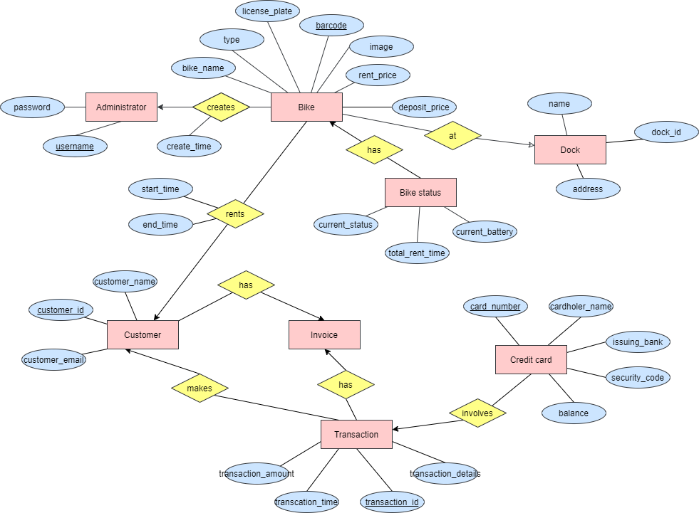

*Figure 4.2. ER Diagram for EcoBike Application*

### 4.2.2. Database Design

#### 4.2.2.1. Database Management System

Database Management System: SQLite

#### 4.2.2.2. Database Diagram

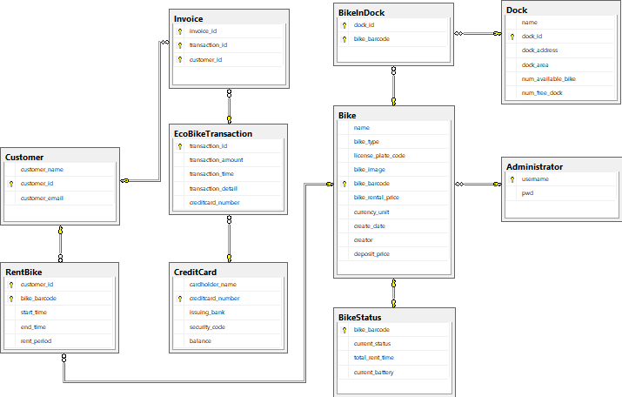

*Figure 4.3. Database Diagram for EcoBike Application*

#### 4.2.2.3. Database Detail Design

| ***No.*** | ***PK*** | ***FK*** | ***Name*** | ***Data type*** | ***Mandatory*** | ***Description*** |
| --- | --- | --- | --- | --- | --- | --- |
| *1* | *x* | *x* | *customer_id* | *int* | *X* | *ID of customer* |
| *2* |  |  | *customer_name* | *varchar(256)* | *x* | *Name of customer renting bike* |
| *3* |  |  | *customer_email* | *varchar(256)* | *x* | *Email of customer renting bike for sending invoice* |

*Table 4.8. Customer table design*

| ***No.*** | ***PK*** | ***FK*** | ***Name*** | ***Data type*** | ***Mandatory*** | ***Description*** |
| --- | --- | --- | --- | --- | --- | --- |
| *1* | *x* | *x* | *username* | *varchar(256)* | *x* | *Username of the administrator* |
| *2* |  |  | *pwd* | *varchar(256)* | *x* | *Password of the administrator used to login* |

*Table 4.9. Administrator table design*

| ***No.*** | ***PK*** | ***FK*** | ***Name*** | ***Data type*** | ***Mandatory*** | ***Description*** |
| --- | --- | --- | --- | --- | --- | --- |
| *1* | *x* | *x* | *dock_id* | *int* | *x* | *ID of dock* |
| *2* |  |  | *dock_name* | *varchar(256)* | *x* | *Name of the dock* |
| *3* |  |  | *dock_address* | *varchar(256)* | *x* | *Address of the dock* |
| *4* |  |  | *dock_area* | *float* |  | *Area of the dock* |
| *5* |  |  | *num_available_bike* | *int* | *x* | *Number of current available bike in dock* |
| *6* |  |  | *num_free_dock* | *int* | *x* | *Number of current available bike slot in dock for returning bike* |

*Table 4.10. Dock table design*

| ***No.*** | ***PK*** | ***FK*** | ***Name*** | ***Data type*** | ***Mandatory*** | ***Description*** |
| --- | --- | --- | --- | --- | --- | --- |
| *1* |  |  | *bike_name* | *varchar(256)* | *x* | *Name of the bike* |
| *2* |  |  | *bike_type* | *varchar(16)* | *x* | *Type of bike* |
| *3* |  |  | *license_plate_code* | *varchar(32)* | *x* | *Code of the license plate of the bike* |
| *4* |  |  | *bike_image* | *varchar(256)* |  | *Path to image of the bike* |
| *5* | *x* | *x* | *bike_barcode* | *int* | *x* | *Barcode of the bike* |
| *6* |  |  | *bike_rental_price* | *float* | *x* | *Price to rent the bike* |
| *7* |  |  | *deposit_price* | *float* | *x* | *Deposit cost to rent the bike* |
| *8* |  |  | *currency_unit* | *varchar(3)* | *x* | *Currency unit used to calculate rental fee and deposit fee* |
| *9* |  |  | *create_date* | *date* | *x* | *Day imported bike data* |
| *10* |  |  | *creator* | *varchar(256)* | *x* | *The administrator who create data for the bike* |

*Table 4.11. Bike table design*

| ***No.*** | ***PK*** | ***FK*** | ***Name*** | ***Data type*** | ***Mandatory*** | ***Description*** |
| --- | --- | --- | --- | --- | --- | --- |
| *1* |  |  | *dock_id* | *int* | *x* | *Id of the dock* |
| *2* |  |  | *bike_barcode* | *int* | *x* | *Barcode of the bike in dock* |

*Table 4.12. Bike In Dock table design*

| ***No.*** | ***PK*** | ***FK*** | ***Name*** | ***Data type*** | ***Mandatory*** | ***Description*** |
| --- | --- | --- | --- | --- | --- | --- |
| *1* |  |  | *bike_barcode* | *int* | *x* | *Barcode of the bike* |
| *2* |  |  | *current_status* | *varchar(4)* | *x* | *‘free’/’rent’* |
| *3* |  |  | *total_rent_time* | *int* | *x* | *Total time that the bike is rented (in minute)* |
| *4* |  |  | *current battery* | *float* | *x* | *Current battery status of the bike* |

*Table 4.13. Bike Status table design*

| ***No.*** | ***PK*** | ***FK*** | ***Name*** | ***Data type*** | ***Mandatory*** | ***Description*** |
| --- | --- | --- | --- | --- | --- | --- |
| *1* | *x* |  | *invoice_id* | *int* | *X* | *ID of the invoice* |
| *2* |  | *x* | *transaction_id* | *int* | *x* | *ID of the transaction* |
| *3* |  | *x* | *customer_id* | *int* | *x* | *ID of the customer* |

*Table 4.14. Invoice table design*

| ***No.*** | ***PK*** | ***FK*** | ***Name*** | ***Data type*** | ***Mandatory*** | ***Description*** |
| --- | --- | --- | --- | --- | --- | --- |
| *1* | *x* |  | *transaction_id* | *int* | *x* | *ID of transaction* |
| *2* |  |  | *transaction_amount* | *int* | *x* | *The amount of money for the transaction* |
| *3* |  |  | *transaction_time* | *DATETIME* | *x* | *Time the transaction is made* |
| *4* |  |  | *transaction_detail* | *varchar(256)* |  | *The content of the transaction* |
| *5* |  | *x* | *creditcard_number* | *int* | *x* | *The number of the credit card* |

*Table 4.15. Transaction table design*

| ***No.*** | ***PK*** | ***FK*** | ***Name*** | ***Data type*** | ***Mandatory*** | ***Description*** |
| --- | --- | --- | --- | --- | --- | --- |
| *1* | *x* | *x* | *customer_id* | *int* | *X* | *ID of customer* |
| *2* | *x* |  | *bike_barcode* | *int* | *x* | *Barcode of the bike being rented* |
| *3* |  |  | *start_time* | *time* | *x* | *Time start renting* |
| *4* |  |  | *end_time* | *time* |  | *Time end renting (null if the bike is currently being rented)* |
| *5* |  |  | *rent_period* | *int* |  | *Total time renting the bike, in terms of minutes (null if the bike is currently being rented)* |

*Table 4.16. Rent Bike table design*

| ***No.*** | ***PK*** | ***FK*** | ***Name*** | ***Data type*** | ***Mandatory*** | ***Description*** |
| --- | --- | --- | --- | --- | --- | --- |
| *1* | *x* | *x* | *card_number* | *int* | *X* | *Number of the credit card* |
| *2* |  |  | *cardholder_name* | *varchar(256)* | *x* | *Name of the cardholder* |
| *3* |  |  | *issuing_bank* | *varchar(256)* | *x* | *Bank in charge of the card* |
| *4* |  |  | *security_code* | *varchar(16)* | *x* | *Security code on the credit card for transaction* |
| *5* |  |  | *balance* | *float* | *x* | *Current balance of the credit card* |

*Table 4.17. Credit Card table design*

Database script:

create table Administrator(username varchar(256) not null primary key,

pwd varchar(256) not null);

create table Bike(name varchar(256) not null,

bike_type varchar(16) not null,

license_plate_code varchar(32) not null,

bike_image varchar(256),

bike_barcode int not null primary key identity(1,1),

bike_rental_price float not null,

currency_unit varchar(3) not null,

create_date date,

creator varchar(256),

constraint FK_Bike_Creator foreign key (creator) references Administrator(username));

create table Dock(name varchar(256),

dock_id int not null primary key identity(1,1),

dock_address varchar(256),

dock_area float,

num_available_bike int,

num_free_dock int);

create table BikeInDock(dock_id int not null,

bike_barcode int not null,

constraint PK_Bike_In_Dock primary key (dock_id, bike_barcode),

constraint FK_BikeInDock_Dock foreign key (dock_id) references Dock(dock_id),

constraint FK_BikeInDock_Bike foreign key (bike_barcode) references Bike(bike_barcode));

create table Customer(customer_name varchar(256) not null,

customer_id int not null identity(1,1) primary key,

customer_email varchar(128) not null);

create table CreditCard(cardholder_name varchar(256) not null,

creditcard_number varchar(25) not null primary key,

issuing_bank varchar(128) not null,

security_code varchar(8) not null,

balance float,

constraint Check_CardBalance check (balance >=0));

create table RentBike(customer_id int not null,

bike_barcode int not null,

start_time time not null,

end_time time,

rent_period int,

constraint PK_Rent_Bike primary key (customer_id, bike_barcode),

constraint FK_RentBike_Bike foreign key (bike_barcode) references Bike(bike_barcode),

constraint FK_RenBike_Customer foreign key (customer_id) references Customer(customer_id),

constraint Check_RenBike_Time check (end_time > start_time));

create table BikeStatus(bike_barcode int not null primary key,

current_status varchar(4),

total_rent_time int,

current_battery float,

constraint FK_BikeStatus_Barcode foreign key (bike_barcode) references Bike(bike_barcode),

constraint Check_BikeStatus_Total_Rent_Time check (total_rent_time >=0),

constraint Check_BikeStatus_Battery check (current_battery >=0),

constraint Check_BikeStatus_Status check (current_status = 'free' or current_status = 'rent'));

create table EcoBikeTransaction(transaction_id varchar(32) not null primary key,

transaction_amount float not null,

transaction_time datetime not null,

transaction_detail varchar(256),

creditcard_number varchar(25) not null,

constraint FK_Transaction_CreditCard foreign key (creditcard_number) references CreditCard(creditcard_number),

constraint Check_Amount check (transaction_amount > 0));

create table Invoice(invoice_id varchar(256) not null,

transaction_id varchar(32) not null,

customer_id int not null,

constraint PK_InvoiceTransactionCustomer primary key (invoice_id, transaction_id, customer_id),

constraint FK_Invoice_Transaction foreign key (transaction_id) references EcoBikeTransaction(transaction_id),

constraint FK_Invoice_Customer foreign key (customer_id) references Customer(customer_id));

## 4.3. Non-Database Management System Files

## 4.4. Class Design

### 4.4.1. General Class Diagram



*Figure 4.4. General Class Diagram for EcoBike Application*

### 4.4.2. Class Diagrams

#### 4.4.2.1. Class Diagram for Package BikeInformation

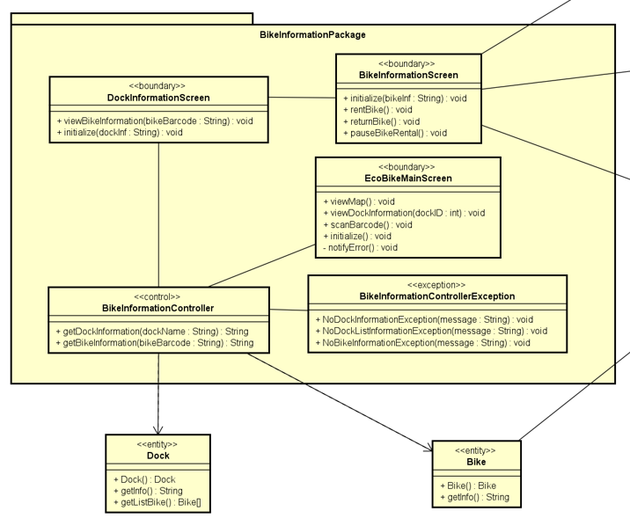

*Figure 4.5. Class Diagram for Package BikeInformation*

#### 4.4.2.2. Class Diagram for Subsystem RentBike

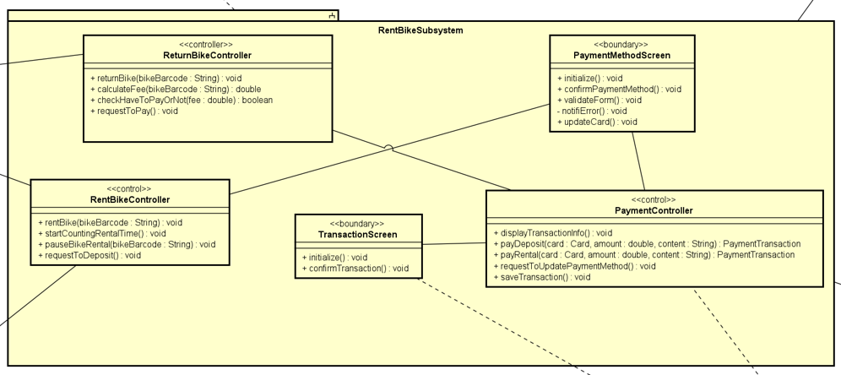

*Figure 4.6. Class Diagram for Subsystem RentBike*

#### 4.4.2.3. Class Diagram for Subsystem InterBank

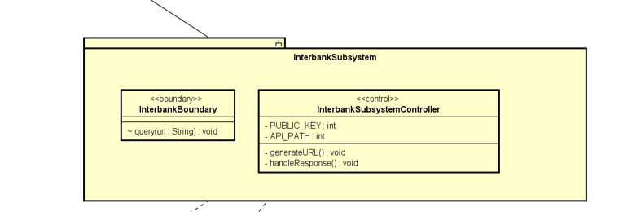

*Figure 4.7. Class Diagram for Subsystem InterBank*

### 4.4.3. Class Design

#### 4.4.3.1. Class RentBikeController

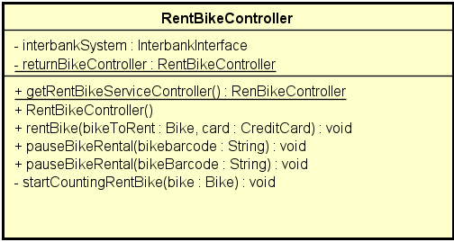

*Figure 4.8. RentBikeController Class Diagram*

| *#* | *Name* | *Data type* | *Default value* | *Description* |
| --- | --- | --- | --- | --- |
| 1 | interbankSystem | InterbankInterface | InterbankInterface | Interbank to proceed transaction |
| 2 | rentBikeController | RentBikeController | null | static instance of the RentBikeController |

*Table 4.18. RentBikeController attributes*

| *#* | *Name* | *Return type* | *Description (purpose)* |
| --- | --- | --- | --- |
| 1 | getRentBikeServiceController | RentBikeController | return static instance rentBikeController of class RentBikeController |
| 2 | rentBike | void | start renting proceed |
| 3 | pauseBikeRental | void | pause counting rental time |
| 4 | startCountingRentBike | void | start counting renal time |

*Table 4.19. RentBikeController operations*

*Parameter*:

* bikeBarcode: bar code of the bike to rent
* card: the credit card to perform transaction (deposit)
* bikeToRent: the bike entities represent the bike to be rented

*Exception*:

* IOException
* RentBikeException If the bike is not currently available, the barcode is not valid
* EcoBikeUndefinedException If there is an unexpected error occurs during the renting process

*Method:*

None

*State*

None

#### 4.4.3.2. Class ReturnBikeController

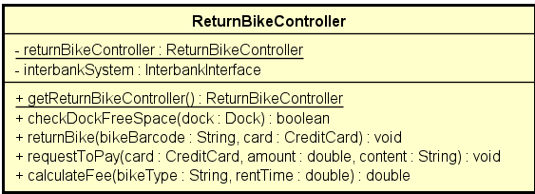

*Figure 4.9. ReturnBikeController Class Diagram*

| *#* | *Name* | *Data type* | *Default value* | *Description* |
| --- | --- | --- | --- | --- |
| 1 | returnBikeController | ReturnBikeController | null | the static instance of ReturnBikeController |
| 2 | interbankSystem | InterbankInterface | InterbankInterface | the interbank to proceed transaction |

*Table 4.20. ReturnBikeController attributes*

| *#* | *Name* | *Return type* | *Description (purpose)* |
| --- | --- | --- | --- |
| 1 | getReturnBikeController | ReturnBikeController | get the static instance of ReturnBikeController |
| 2 | checkDockSpace | boolean | check whether the dock have empty slots |
| 3 | returnBike | void | proceed return bike process |
| 4 | requestToPay | void | proceed pay for rental process |
| 5 | calculateFee | double | return the fee of the rental process |

*Table 4.21. ReturnBikeController operations*

*Parameter*:

* dock: the entity represent a dock
* bikeBarcode: bike bar code represent as a string
* card: the entity represent a card
* bikeType: type of current bike

*Exception*:

* RentBikeException If the bike is not currently available, the barcode is not valid
* EcoBikeUndefinedException If there is an unexpected error occurs during the renting process

*Method*

None

*State*

None

#### 4.4.3.3. Class PaymentController

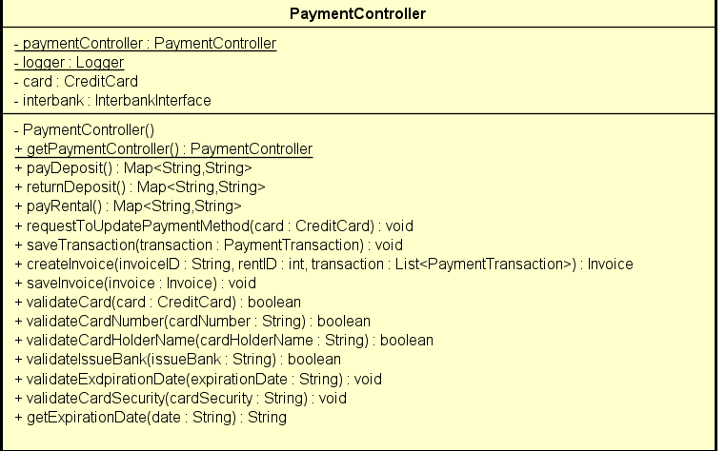

*Figure 4.10. PaymentControllerClass Diagram*

| *#* | *Name* | *Data type* | *Default value* | *Description* |
| --- | --- | --- | --- | --- |
| 1 | paymentController | PaymentController | null | static instance of PaymentController |
| 2 | logger | Logger | Logger | logger to log interaction |
| 3 | card | CreditCard | null | credit card to perform transaction |
| 4 | interbank | Interbank | Interbank | interbank to perform transaction |

*Table 4.22. PaymentController attributes*

| *#* | *Name* | *Return type* | *Description (purpose)* |
| --- | --- | --- | --- |
| 1 | payDeposit | Map<String, String> | start pay deposit process |
| 2 | returnDeposit | Map<String, String> | start return deposit process |
| 3 | payRental | Map<String, String> | start pay rental process |
| 4 | requestToUpdatePaymentMethod | void | start request to update payment method process |
| 5 | saveTransaction | void | save current transaction |
| 6 | createInvoice | Invoice | create invoice for current transaction |
| 7 | saveInvoice | void | save current invoice |

*Table 4.23. PaymentController operations*

*Parameter*:

* transaction: the entity represent a transaction
* invoice: the entity represent a invoice
* card: the entity represent a card

*Exception*:

* EcoBikeUndefinedException If there is an unexpected error occurs during the renting process
* SQLException if there is an unexpected error with the database

*Method*

None

*State*

None

#### 4.4.3.4. Class BikeInformationScreenHandler

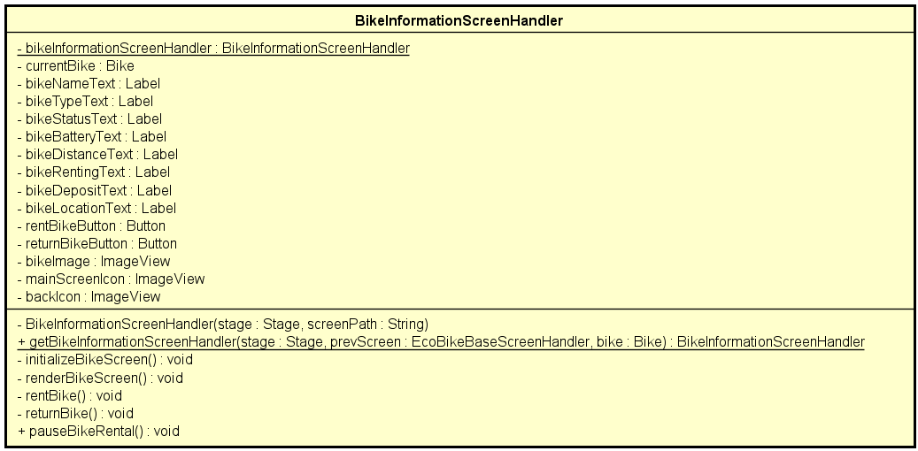

*Figure 4.11. BikeInformationScreenHandler Class Diagram*

| *#* | *Name* | *Data type* | *Default value* | *Description* |
| --- | --- | --- | --- | --- |
| 1 | currentBike | Bike | null | the bike the screen is showing |
| 2 | bikeNameText | Label | null | label of the name of the bike |
| 3 | bikeTypeText | Label | null | label of the type of the bike |
| 4 | bikeStatusText | Label | null | label of the status of the bike |
| 5 | bikeBatteryText | Label | null | label of the battery of the bike |
| 6 | bikeDistanceText | Label | null | label of the estimation distance that the bike can travel |
| 7 | bikeRentingText | Label | null | label of the renting price per hour of the bike |
| 8 | bikeDepositText | Label | null | label of the amount of money needed to deposit to rent the bike |
| 9 | bikeLocationText | Label | null | label of the location of the bike |
| 10 | returnBikeButton | Button | null | button to return this bike |
| 11 | rentBikeButton | Button | null | button to rent this bike |

*Table 4.24.* BikeInformationScreenHandler *operations*

| *#* | *Name* | *Return type* | *Description (purpose)* |
| --- | --- | --- | --- |
| 1 | renderBikeScreen | void | render the screen with information of the bike |
| 2 | rentBikeS | void | start rent bike process |
| 3 | returnBike | void | start return bike process |

*Table 4.25.* BikeInformationScreenHandler *operations*

*Parameter*:

None

*Exception*:

* IOException if there is unexpected error with the IO

*Method*

None

*State*

None

# 5. Design Considerations

## 5.1. Goals and Guidelines

Goals:

* Provide a user-friendly application
* Provide an eye-catching interface and convenient experience for users
* The response time for the system is 1 second at normal and 2 seconds during a peak load

Guidelines:

* Obligate the coding convention in Java, and OOP principles.
* Avoid hard-coding
* Write comments for codes
* Structure the doc for maintenance

## 5.2. Architectural Strategies

Our intention is to reuse components

* Programming Language: Java
* Database: MySQL
* UML: Astah
* GUI: Scene Builder

We’re always looking toward minimizing the memory and space usage; reduce the complexity to speed up the response time, and improve the performance. We’re also concerned about the maintenance. For the future, we’re looking forward to updating the system, integrating new features such as admin to manage the crud, the statistics, the profit.

## 5.3. Coupling and Cohesion

### 5.3.1. Coupling

#### 5.3.1.1. Content coupling

| Related modules | Description | Improvement |
| --- | --- | --- |
| No related module | Our modules are self-contained and don’t rely on other modules to operate | No improvement |

#### 5.3.1.2. Common coupling

| Related modules | Description | Improvement |
| --- | --- | --- |
| No related module | We only use static with Singleton pattern to share the controller instance between boundaries to control the flow of the programs.  Some constants exist in the system, but only with careful usage shared between the related modules | No improvement |

#### 5.3.1.3. Control coupling

| Related modules | Description | Improvement |
| --- | --- | --- |
| No related module | Our methods are designed to carry out only one specific task, so no control coupling existed | No improvement |

#### 5.3.1.4. Stamp coupling

| Related modules | Description | Improvement |
| --- | --- | --- |
| RentBikeServiceController | In module RentBikeServiceController, the Bike entities was used as an argument for the calculateFee method, which only need bikeType and totalRentTime as arguments | Fix the method to accept only needed arguments instead of the accepting Bike entities as the argument |

#### 5.3.1.5. Data coupling

| Related modules | Description | Improvement |
| --- | --- | --- |
| Controllers and Boundaries modules | Boundaries need data to render GUI, which is acceptable | No improvement |

### 5.3.2. Cohesion

#### 5.3.2.1. Coincidental cohesion

| Related modules | Description | Improvement |
| --- | --- | --- |
| No module | The only visible coincidental cohesion in our project might be the class Configs, which contains some constant share between some controllers and entities | No improvement |

#### 5.3.2.2. Logical cohesion

| Related modules | Description | Improvement |
| --- | --- | --- |
| No module |  | No improvement |

#### 5.3.2.3. Temporal cohesion

| Related modules | Description | Improvement |
| --- | --- | --- |
| Controller  View, | In our project, we put all controllers into a Controller package, screen handlers into a View package, which might be considered temporal cohesion | No improvement |

#### 5.3.2.4. Procedure cohesion

| Related modules | Description | Improvement |
| --- | --- | --- |
| RentBikeServiceCon-troller | Consist of validating methods | No improvement |

#### 5.3.2.5. Communicational cohesion

| Related modules | Description | Improvement |
| --- | --- | --- |
| No module |  | No improvement |

#### 5.3.2.6. Sequential cohesion

| Related modules | Description | Improvement |
| --- | --- | --- |
| No module |  | No improvement |

#### 5.3.2.7. Information cohesion

| Related modules | Description | Improvement |
| --- | --- | --- |
| DBUtils  JSONUtils | All methods are to perform database queries or manipulate json string | No improvement |

#### 5.3.2.8. Functional cohesion

| Related modules | Description | Improvement |
| --- | --- | --- |
| Most of the modules |  | No improvement |

In our software design, we detect that there are still some components that have Control Coupling and Communicational Cohesion problems.

We are trying our best to resolve these problems, decrease Coupling level and increase Cohesion level. However, due to lack of time, we might not be able to fix this before the announced deadline.

## 5.4. Design Principles

We design simple classes follow SOLID principles that means:

* A class should have only one job, one responsibility.
* Software entities are open for extension but close for modification.
* We also use interfaces, abstract classes. So, subclasses should be substitutable for their base classes.
* Use specific interfaces if necessary instead of using general purpose interfaces which do not use.
* We put all classes with the same properties into one package to manage easily. Therefore, we can reuse source code, adapt to any changing requirements.

## 5.5. Design Patterns

Facade pattern:

* We use InterbankInterface for communication between software and interbank subsystem. It decrease the overall complexity of our application and provides an easier interface for communication

Singleton pattern: